



Prevention and Tackling Bullying

Gloucester House
The Tavistock Pupils Day Unit

Policy reviewed | June 2025
Next review date: | June 2028

“I've learned that people will forget what you said, people will forget what you did, but people will never forget how you made them feel.”
― Maya Angelou

Contents
Introduction: 2
Gloucester House Ethos 2
School responsibilities 2
(i) Section 89 of the Education and Inspections Act 2006: 2
(ii) Equality Act 2010 2
(iii) Safeguarding children and young people-Children Act 1989 3
(iv) Criminal Law 3
While bullying itself is not a specific criminal offence, some behaviours associated with bullying may be considered criminal acts. For example, under the Malicious Communications Act 1988, it is an offence to send an electronic communication with the intent to cause distress or anxiety, or to convey messages that are indecent, grossly offensive, threatening, or knowingly false. 3
Where school staff believe that a criminal offence may have been committed, they will seek advice and support from the police, in line with the school’s safeguarding procedures. 3
(v) Bullying outside school premises 3
Roles and responsibilities of staff: 3
The Steering Committee will: 4
Key contacts 4
Purpose of the policy: 4
Developing the policy: 5
SLT working with Pupil Parliament: 5
When developing this policy we took account of: 5
Links to other policies: 5
Bullying can be: 6
The difference between bullying and other hurtful behaviour: 6
Preventing Bullying: 7
Whole school ethos and Environment: 7
Whole School Activities: 7
At playtimes we: 8
Curriculum: 8
Pupils Learn: 8
In the class we will: 9
Training and Support for Staff: 9
Involving Pupils: 9
Involving Parents and Carers: 9
Dealing with Bullying: 10
Recording and Reporting: 11
Sharing the policy 12
Appendix 1 13
Advice to children 13
Advice to bystanders 13
What to do if your child is being bullied: 14
What to do if your child is bullying someone else: 15
Appendix 2 16

Introduction:

Gloucester House Ethos

Gloucester House is committed to providing a caring, friendly, respectful and safe learning environment for all of our pupils. We promote an inclusive ethos that focuses on respecting one another and celebrating difference and diversity.

Bullying and prejudice-based language of any kind—whether involving pupils, adults towards pupils, staff, or parents—is unacceptable. However, at Gloucester House, pupils often display behaviours that reflect unmet needs or difficulties with social communication. We have a robust system of challenge and support in place to help pupils manage and address these behaviours. Our aim is to support them in understanding the impact of their actions and making positive changes. While bullying and prejudice are not tolerated, we recognise that they are dynamic behaviours that must be actively addressed in the context of working with pupils who have complex and severe Social, Emotional, and Mental Health (SEMH) needs.

We understand the devastating and lasting effect being bullied can have on some pupils and we will deal with all incidents equally seriously, quickly and effectively, whether it has taken place in or outside of school.

Preventing and tackling bullying is part of our work to support pupils’ social and emotional development and part of our commitment to becoming a healthy school.

We aim to empower staff and pupils to be confident to recognise, interrupt and confront potential bullying situations.

School responsibilities

We are aware of our statutory responsibilities in regard to preventing and tackling bullying as set out in

(i) Section 89 of the Education and Inspections Act 2006:
Every school must have measures to encourage good behaviour and prevent all forms of bullying amongst pupils. These measures should be part of the school’s behaviour policy which must be communicated to all pupils, school staff and parents;
The headteacher may take disciplinary action for poor behaviour occurring off the school premises or outside the lawful control of school staff, where it is reasonable to do so. This includes incidents during travel to and from school, online behaviour, and in the wider community.

(ii) Equality Act 2010
As part of our responsibilities under the Public Sector Equality Duty (Equality Act 2010), we are committed to eliminating discrimination, harassment and victimisation, including addressing prejudice and prejudice-based bullying. This duty applies to the following protected characteristics: disability, sex, race, religion or belief, sexual orientation, gender reassignment, and pregnancy and maternity.

We take our responsibility for meeting the Public Sector Equality Duty (Equality Act 2010) seriously and take active steps to:
-eliminate unlawful discrimination, harassment, victimisation
-advance equality of opportunity between people who share a protected characteristic and people who do not share it;
-foster good relations between people who share a protected characteristic and people who do not share it.

(iii) Safeguarding children and young people-Children Act 1989
A bullying incident will be treated as a child protection concern if there is reasonable cause to suspect that a child is suffering, or is likely to suffer, significant harm. In such cases, school staff will follow the school’s safeguarding procedures and report concerns to Camden Local Authority’s safeguarding team.
Even when a bullying incident does not meet the threshold for a safeguarding referral, the school will draw on appropriate external support services to support the pupil who has been bullied and to help address any underlying needs or circumstances that may have contributed to bullying behaviour.

(iv) Criminal Law

While bullying itself is not a specific criminal offence, some behaviours associated with bullying may be considered criminal acts. For example, under the Malicious Communications Act 1988, it is an offence to send an electronic communication with the intent to cause distress or anxiety, or to convey messages that are indecent, grossly offensive, threatening, or knowingly false.

Where school staff believe that a criminal offence may have been committed, they will seek advice and support from the police, in line with the school’s safeguarding procedures.

(v) Bullying outside school premises

- Headteachers have a specific legal power to respond to incidents of inappropriate or harmful behaviour that occur outside of the school premises, even when pupils are not under the direct supervision of school staff.
- This could relate to bullying incidents occurring anywhere off the school premises, such as on school or public transport or outside local shops.
- Where bullying outside school is reported to school staff, it should be investigated and acted on.
- The headteacher should also consider whether it is appropriate to notify the police or local authority.
- If the misbehaviour could be criminal or poses a serious threat to a member of the public, the police should always be informed.

Roles and responsibilities of staff:

The Senior Leadership Team will:

- Ensure that the policy is implemented and reviewed regularly
- Provide a regular report of incidents of bullying to the Steering Committee
- Monitor bullying and harassment of pupils in terms of difference and diversity (i.e.
different groups) and take action if there is a cause for concern
- Provide a report on the effectiveness of the anti-bullying policy
- Ensure the policy is regularly publicised to the whole school community and the message that bullying is not accepted is reinforced through whole school activities and information
- Ensure that all staff receive sufficient training to be equipped to identify and deal with bullying
- Ensure that the curriculum design and content address the development of an anti-bullying culture
- Ensure that PHSE lessons and activities support and develop an anti-bullying ethos in content and delivery
- Regularly review the policy in the light of incidents
- Include regular updates to staff through the annual safeguarding training
- Include information in the newsletter/on the website about what the school is doing to prevent and tackle bullying

The Steering Committee will support the Operational Management in all attempts to address bullying effectively in Gloucester House.

The Steering Committee will:

- Require Gloucester House to keep accurate records of all incidents of bullying and report on them to the Steering Committee on a termly basis.
- Require SLT to report annually to the Steering Committee about the effectiveness of school anti-bullying strategies.
- Notify the Headteacher of any request from a parent or carer to investigate incidents of bullying and ask the head teacher to conduct an investigation and report back to the Steering Committee.
- The Steering Group will respond within ten days to the parent or carer and keep them regularly updated with regards to the investigation and, where possible, meet with the parent or carer to ensure they are satisfied with the outcome.

Key contacts
- Staff responsible for bullying prevention (SLT)
- Staff responsible for monitoring bullying incidents (CL)
- Lead Steering Committee member – Mark Freestone
- Online safety coordinator (HT)

Purpose of the policy:
This policy sets out Gloucester House’s approach to preventing and dealing with bullying that occurs between pupils:
- On Gloucester House’s premises
- Near Gloucester House
- On trips
- On the journey between Gloucester House and home
- Online or by text at Gloucester House or outside of school hours

The policy aims to ensure that:
- All staff, teaching and non-teaching staff, members of the Steering Committee, pupils and Parents/Carers have an understanding of what bullying is
- All staff teaching and non-teaching staff know Gloucester Houses policy on bullying, and follow it when bullying occurs
- Pupils, parents and carers know what Gloucester houses policy is on bullying, and what they should do if bullying occurs
- Pupils and parents and carers are assured that they will be supported when bullying is reported
- Effective and consistent action is taken both to prevent and address bullying behaviour

Developing the policy:
This policy was produced by the whole school community. Through PHSE lessons, class meetings and whole school meetings, parent/carer work and staff meetings.

SLT working with Pupil Parliament:
- Looks at and reviews policy
- Discusses bullying and what can be done to prevent it
- Agrees the definition of bullying and the approach Gloucester House should take to prevent it
- Helps to plan the Anti Bullying week

When developing this policy we took account of:
  - DfE guidance “Preventing and Tackling Bullying” July 2017
  - Camden’s Example Anti-Bullying Policy
  - Ofsted Inspection Framework
  - Ofsted’s briefings on inspections in relation to preventing homophobic bullying and equalities
  - KCSIE

Links to other policies:

This policy links to our behaviour, equalities, safeguarding and PSHE policies and is part of
our approach and commitment to promoting positive behaviour, dealing with inappropriate behaviour and improving the health and wellbeing of children.

What is bullying? Definitions:

We have used the Department for Education’s definition in their guidance; Preventing and Tackling Bullying” 2017

"Bullying is behaviour by an individual or group, repeated over time, that intentionally hurts another individual or group either physically or emotionally. It can take many forms (for example, cyberbullying via text messages or the internet), and is often motivated by prejudice against particular groups."

This means that to be described as bullying, behaviour has to be
- Deliberately hurtful
- Is repeated often over a period of time
- It is difficult for those being bullied to defend themselves

Bullying can be:
- Direct physical bullying – e.g. hitting, kicking, pushing, or other forms of physical aggression.

- Direct verbal bullying – e.g. name-calling, verbal abuse, threats, offensive mimicry (e.g. mocking someone’s accent or speech), and the use of discriminatory or demeaning language.

- Indirect bullying (also known as relational or social bullying) – e.g. spreading rumours, social exclusion, manipulating friendships, sharing someone’s private information, or graffiti.

- Online bullying (cyberbullying) – bullying through digital technology, such as email, messaging apps, social media, blogs, chat rooms, and the sharing of harmful or humiliating content (e.g. videos or photos).

- People can be bullied because they are different or are perceived to be different and it is often motivated by prejudice against particular groups or because of characteristics or features about which the person under attack can do nothing.

Bullying can relate to
- race, religion, culture or belief (or no belief)
- special educational needs and disabilities
- young carers
- looked after children
- background
- gender
- appearance and size
- ability and attainment
- Sexist or sexual bullying (bullying based on a person’s sexuality)
- Homophobic bullying (a dislike or fear of someone who is or is perceived to be lesbian, gay or bisexual)
- Transphobic bullying (a dislike or fear of someone who is or is perceived to have changed their gender from male to female or female to male or someone who is difficult to categorise as female or male)

“Sticks and stones can break your bones, but words can break hearts” Tim Minchin

The difference between bullying and other hurtful behaviour:

Our definition of bullying does not include conflict and/or friendship problems between pupils and young people or one-off incidents. However, these problems are still taken seriously and dealt with promptly to prevent them developing into bullying behaviour.

Bullying can also happen between adults and pupils and between adults. We strongly believe that all forms of prejudice and prejudice-based behaviour and or bullying are unacceptable and should be dealt with both thoroughly and seriously.

Preventing Bullying:

Our approach to preventing bullying involves direct teaching about bullying and its consequences, celebrating differences and diversity and promoting positive behaviour.
We do this through:
- Whole school ethos and environment
- Whole school and playground activities
- Curriculum
- Training and support for staff
- Involving Pupils
- Involving Parents and Carers

Whole school ethos and Environment:

We aim to create a positive, safe and inclusive environment that reduces the opportunities for bullying to take place, promotes positive relationships and where pupils can discuss bullying openly.

- Staff model respectful behaviour and positive communication, both with pupils and with other adults in the school.
- Staff support pupils to develop respect for others and to take responsibility for their own behaviour.
- Staff explicitly teach and reinforce expected behaviours, and celebrate and reward positive choices.
- Staff consistently challenge the use of prejudice-based language, explaining why it is unacceptable and how it can be harmful.
- Staff encourage pupils to speak to a trusted adult if they are worried, upset, or feel unsafe.
- Staff actively recognise and celebrate diversity, fostering an inclusive and respectful school culture.
- We provide a range of structured activities during break and lunchtimes that promote cooperation, teamwork, and positive social interactions.
- Break and lunchtimes are well supervised, and support staff are trained to organise inclusive activities and encourage all pupils to join in.
- We regularly talk to pupils about how safe they feel in the playground and around the school.
- We take particular care to support pupils with special educational needs and disabilities (SEND), who may be more vulnerable to bullying. We ensure they feel safe and included and help them build the social and emotional skills needed to manage relationships and navigate social situations.

Whole School Activities:
- We organise specific class lessons on bullying and its consequences and what to do if they see or experience it
- We carry out annual surveys how safe pupils feel in school, whether they have experienced or seen bullying and how well they feel the school deals with bullying
- We hold a week of activities focused on friendship and anti-bullying to recognise national Anti-Bullying Week
- We use restorative approaches for dealing with conflict
- Through whole school activities and the curriculum pupils are encouraged to think about ‘sorry’ and ‘thank-you’ and to repair with others

At playtimes we:
- Continually improve playtimes and reduce dominance of the playground by having structured planned playtimes
- Adults set up and guide activities—encouraging turn-taking, sharing, and pupil contributions to decision-making—while children choose from indoor play options, blending structure with autonomy for social development
- Provide and encourage constructive and collaborative play opportunities
- Provide on-going space for staff to discuss playground issues and support around these.
- Observe pupils at play and provide support and encouragement for pupils who are left out

Curriculum:

An understanding of what bullying is, how it feels, why people bully and how to prevent it, is taught through our PSHE and RE schemes of work, assemblies, class meetings and literacy.

We aim to help pupils develop the skills and attitudes to resolve conflict fairly, make and maintain positive friendships and respect other people and the differences between them. We use ‘behaviour reflections’ in our consequences system to work with children 1:1 on this.

We use “I Time” as a way of restorative approaches for dealing with conflict.

Pupils participate in social skills sessions that are designed to improve their communication skills and gives guidance on how to communicate positively and maintain good relations.

We provide regular opportunities for pupils to regularly come together to play and build relationships with one another. This work is part of our ‘therapeutic milieu’. We also provide specific individual and group interventions as indicated. We promote positive relationships and positive behaviour and help pupils share responsibility for creating a better learning and caring environment though our ethos and policies.

Teaching about bullying and its consequences are also discussed in circle time/lessons, and in ‘talking spaces’ provided for class groups, and the entire community of staff and pupils, individuals, small groups.

Pupils Learn:
- What bullying is, how it feels, why people bully, what to do about it and how to prevent it
- About the differences between people and about the importance of being inclusive and celebrating difference and diversity
- About the impact of prejudice and discrimination
- To develop their skills to manage feelings, develop empathy, resolve conflict fairly, how to cope with friendship problems and make and maintain and nurture positive relationships
- How to keep safe and behave responsibly when using the internet and mobile phones

In the class we will:
  - Remind pupils of acceptable behaviour and bring out moral issues in the curriculum (in RE, Science, History, Geography, PHSCE, and circle times).
  - Ensure school rules are visible in the classrooms and around Gloucester House
  - Hold (at least) annual anti bullying (Friendship) weeks
  - Hold annual Black History/Cultural diversity weeks
  - Schemes of work includes activities on social and emotional aspects of learning
  - Celebrate differences at Gloucester house

We use stories that enable a greater understanding of difference and diversity through their use of language, cultural attitudes and images, avoiding stereotypes, racism and sexism and celebrate difference such as including pupils with disabilities and those with same sex parents when teaching about families.

Training and Support for Staff:

Staff are supported through Whole Team meetings, regular de-brief meetings and Core Teams. We have annual safeguarding training which includes an update of this policy to ensure that staff are aware of how to identify bullying and what to do if it occurs.

Involving Pupils:
Pupils play an important role in shaping and reviewing our anti-bullying policy. Through the Pupil Parliament, class meetings, and regular feedback opportunities, pupils are encouraged to share their views and experiences. We carry out child-friendly questionnaires to find out how safe pupils feel in school and online, whether they have experienced or witnessed bullying, and how effectively they feel the school responds to such issues.

These activities include exploring pupils’ experiences in relation to social media and any concerns linked to protected characteristics, such as race, disability, gender identity, religion, or sexual orientation. This feedback informs our whole-school approach to safeguarding and helps us ensure that all pupils feel safe, respected, and included.

Involving Parents and Carers:
We believe that parents and carers have a very important role in supporting the school's anti-bullying policy and in actively encouraging their child to be a positive member of the school. We ask all parents and carers to sign the Home-School agreement when their child starts school. This agreement sets out what parents and carers can expect from our school and what is, in turn expected from parents and carers. This includes our approach to addressing bullying (it is made clear that acts of bullying do not meet the expectations that we have at Gloucester House).

We welcome and actively encourage discussions and an open dialogue with Parents/Carers about bullying in all of its forms. We also have an information board in our Parent/Carer room and on our website providing information and guidance on online safety and also other literature/advice on bullying.

Dealing with Bullying:
All of the staff in our school takes all forms of bullying and prejudice-based language seriously and will deal with it promptly to both prevent bullying from taking place and also addressing any concerns/issues.

We discuss how to manage bullying regularly in the Whole Team and Multidisciplinary meetings and treat all bullying incidents seriously- no matter what form of bullying it is.

We will investigate and act upon any bullying incident that is reported to school staff, including any bullying taking place outside of school e.g. on school or public transport, outside local shops or online. We will also consider whether it is appropriate to notify the police of the incident.

Understanding and helping to overcome bullying is part of our work to support pupils’ social and emotional development and to collectively create and maintain a nurturing community which looks after the wellbeing of its members.

We:

- Record all bullying incidents and address them in whole team meetings, debriefs, and follow-ups to resolve concerns.
- Raise bullying-related issues in class meetings or PSHE lessons to discuss strategies and responses.
- Respond to incidents promptly, consistently, and thoroughly.
- Set whole-class targets around friendship and teamwork, with positive behaviour rewarded through class treats.
- Apply clear, proportionate sanctions for bullying (e.g. missed break time, withheld rewards, or missed privileges).
- Promote restorative approaches and consistently recognise and reward positive behaviour.
- Ensure fair and consistent behaviour management across all staff.
- Use clear language to state that bullying is unacceptable.
- Support pupils to understand that bullying behaviour often has underlying causes such as fear, unhappiness, or feeling bullied themselves.
- Involve parents and carers through family meetings where appropriate.

If bullying occurs we will:
- Talk to the pupils involved separately to ascertain what has been happening and why. We will also talk to any child/adult that has witnessed the bullying to form a wider view on the bullying
- Help the child who is bullying to recognise the consequence of their behaviour, and work with them to begin to understand the feeling(s) which led them to bully others. Consider the underlying reasons for their behaviour and if they could benefit from support or interventions to help them manage their behaviour and/or develop their personal and social skills. These discussions will take place in debrief, whole team meeting, core teams and other spaces as indicated.

- Be clear that bullying is not tolerated at school. Expect the child who is bullying to apologise for their actions and to agree to stop their behaviour.

- Tell the parents/carers of the pupils involved and keep them informed of how the incident is being dealt with and whether the bullying has stopped

- Use restorative approaches which hold the child who is bullying accountable for their actions
- Use formal sanctions, such as keeping them in at playtime/recovery time (the sanction used will depend on the severity and persistence of the bullying behaviour).
- Continue to closely monitor the situation and put in place intervention measures if the bullying appears to be carrying on or to have started again

We will also:
- Record all incidents of bullying and prejudice-based language (including race, disability, religion, ethnicity, gender, SEN, homophobic/transphobic, and appearance). Follow up will be documented on day sheets and follow up sheets.
- Spend time talking to the child who has been or is being bullied to see if they could benefit from further support. We consider issues at the Whole Team meetings for both pupils being bullied and those bullying to plan further support and or to put in place interventional measures to help them develop their personal and social skills
- Address with other pupils and young people who may have been bystanders, observing or supporting the bullying behaviour, how they could intervene to stop bullying behaviour in future
- Provide support training for staff to help identify bullying and work to prevent it happening and to intervene effectively to stop it

Recording and Reporting:
Staff who identify or who are told about bullying or prejudice-based language make a written record of this. All incidents (whether an isolated or recurrent) defined as bullying are logged on the class day-sheet and sometimes on an IRF (Incident Report Form). All incidents are monitored on the weekly monitoring sheet and records of bullying are reviewed to ensure they have been resolved effectively.

We encourage staff, steering group members, pupils and parents/carers to discuss bullying or prejudice based language and we have a range of ways this can be done including:
- Talking to any member of staff
- Talking to the lead teacher responsible for behaviour

Information is recorded about:
- The type of incident or bullying e.g. racist, sexist
- The kind of behaviour e.g. verbal, physical, cyber
- A description of what happened and who was involved
- How the incident or bullying was dealt with and resolved
- How parents were involved
- Whether as a result of the response the incident or bullying has stopped
- Pupils involved in the incident or who have been bullied and their parents will be asked for feedback on how well they felt the school dealt with the it

The data is reported to the Steering Group annually and the Steering Group rep responsible for safeguarding is updated on bullying incidents regularly.

Evaluation

Following any bullying we use the feedback from parents and pupils to evaluate our approach and make changes as needed. We analyse data on bullying and prejudice-based language to help plan future actions to reduce bullying and eliminate discrimination.

Support for pupils and parents

Due to the nature of our provision we have close working relationships with pupils and parents/carers so we are able to deal with the issues that arise from the difficulties their children present. Parents/carers consistently report that we are easy to approach in terms of their concerns .

Pupils are less consistent about us being easy to approach in terms of their concerns so we are introducing a written complaints form for them to use and us to respond to. (See Appendix 2)

We have also attached the general Camden guidance for pupils and parents (Appendix 1)

Sharing the policy

Key information from this policy will be incorporated into the following documents
- Induction documents
- Home-school contract/agreement

A full copy of this policy is freely available to parents and carers on request and a copy is on the school website. Copies are supplied to other professionals whose work relates to bullying prevention or who may be involved in its delivery.

Appendix 1

Advice to children
- If you are a victim of bullying (whether in or outside of school), it is very important to tell somebody you trust. You can tell a member of staff or anyone you want to talk to.
- The school will always take you seriously and take action to stop the bullying and support you to feel safe again
- If you cannot tell anyone at school, you can tell your parents who will tell us.
- You can also email, text and have an online chat with a counsellor at Childline. Their website is: http://www.childline.org.uk
- Friends of victims should tell staff or a parent
- Nobody deserves to be bullied– remember, you have a right for this not to happen to you and it is not weak to tell someone

Advice to bystanders
Do not ignore or support bullying behaviour if you see it happening to someone else. If you do see someone being bullied please:
- Do not join in even if you feel pressured to do so
- Tell a member of staff what you have seen
- Tell your parents or carers or someone else you trust
- If you feel safe to do so, tell the bully/bullies they should stop
- You could tell the person who has been bullied that you don’t agree with what’s happened. When people are bullied they can feel very alone and can blame themselves, so it’s good to have support
- If you are not sure what you should do, you could call Childline which is a confidential advice service for children. The number is: 0800 1111
- You can also email, text and have an online chat with a counsellor at Childline.
Their website is: http://www.childline.org.uk

If you are bullying someone:

- Stop!
- Talk to someone about what you’re doing and ask for help to understand and change your behaviour – and to find out how you can apologise and make amends to the person you’ve been bullying.
- If you are not sure what to do, you could call Childline which is a confidential advice service for children. The number is: 0800 1111. You can also email, text and have an online chat with a counsellor at Childline. Their website is:
http://www.childline.org.uk
They won’t judge you and they understand that there are often many reasons why children and young people bully others, sometimes because they themselves have been bullied.

Guidance for parents and carers

We have a booklet for parents and carers with guidance on what to do if their child is being bullied or is bullying others

What to do if your child is being bullied:
Your child may not tell you that he or she is being bullied. However, you may notice some changes in his or her behaviour, including:
- Be unwilling to talk about their day
- Look less happy
- Come home with cuts and bruises
- Come home with toys and things you have not bought for them
- Take things from home without you knowing
- Avoid certain children or activities
- Be reluctant to go to school
- feeling unwell, often with a headache
- anxiety
- aggression towards you or others in your family
- bedwetting
- waking in the night

These things can happen for other reasons but they can be a sign of bullying so it’s important to find a quiet time to talk to your child about your concerns. It might also help to talk to others who know and care for your child including their teachers.

If your child is being bullied:
- Take time to listen to your child and stay calm
- Calmly talk with your child
- Explain to them that bullying is unacceptable and that no one should have to put up with it. Promise to do all you can to stop it.
- Write down what your child has said. If it involves cyberbullying, keep any evidence of emails and texts
- Encourage your child to talk to their teacher, case coordinator or someone at the school
- Never intervene with other children or children’s parents, but let the school know.
- Contact your child's teacher or case coordinator as soon as possible to let them know your concerns. The school will take any incident of bullying extremely seriously and will deal with it quickly to find out why it has happened and to prevent it happening again
- Staff may not know about the bullying and will need to know what has happened and will discuss with parents and carers action to be taken
- Staff will update parents and carers about what they are doing to resolve the issue and when it has been resolved
- If you are not satisfied with the response you get and any action taken, you should contact the Head of service, one of the deputies or the Headteacher with your concerns.
- If you remain dissatisfied, you should follow the school's complaints procedure. There is a leaflet on Camden Council’s website giving advice about how to complain about a school service: http://www.camden.gov.uk/schoolcomplaintsleaflet
- Call or go on the website of one of the organisations dedicated to supporting parents and carers. They will give you independent advice and support. For example, Parentline Plus on 0800 800 2222 or the Parents Anti-Bullying Helpline on 08451 205 204.

What to do if your child is bullying someone else:
It can be a shock to parents and carers that their child could be bullying another child in the school. There are many reasons why some children and young people bully others. Sometimes it’s because they are copying someone at school or elsewhere, or being encouraged to bully or that they have been a victim of bullying themselves. It may be hard to spot although one sign could be that they come home with toys, food and other things that you have not bought for them.

Children who bully others may also suffer from long lasting consequences and may continue with bullying behaviour into their adult lives. It is important that children receive help and the issues are dealt with straight away. You should:
- Talk with your child and explain why bullying is wrong
- Make an appointment to speak to their class teacher or form tutor to talk about how the bullying can be dealt with
- Call or go on the website of one of the organisations dedicated to supporting parents and carers. They will give you independent advice and support. For example, Parentline Plus on 0800 800 2222 or the Parents Anti-Bullying Helpline on 08451 205 2

Appendix 2

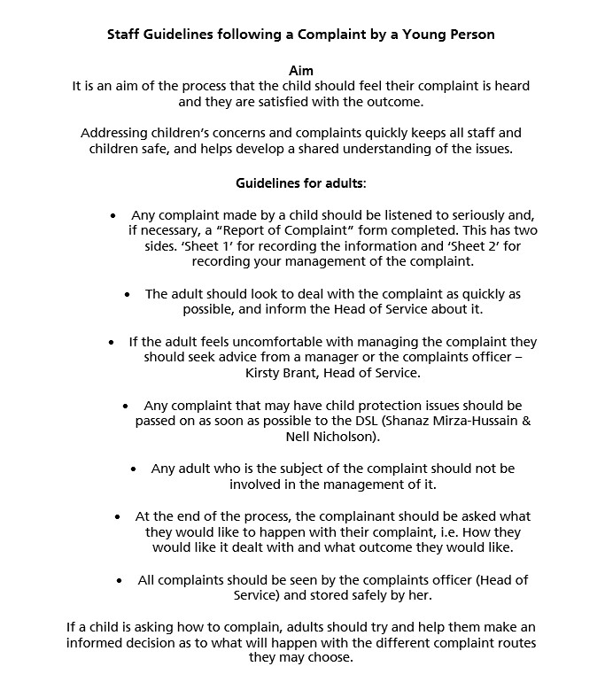

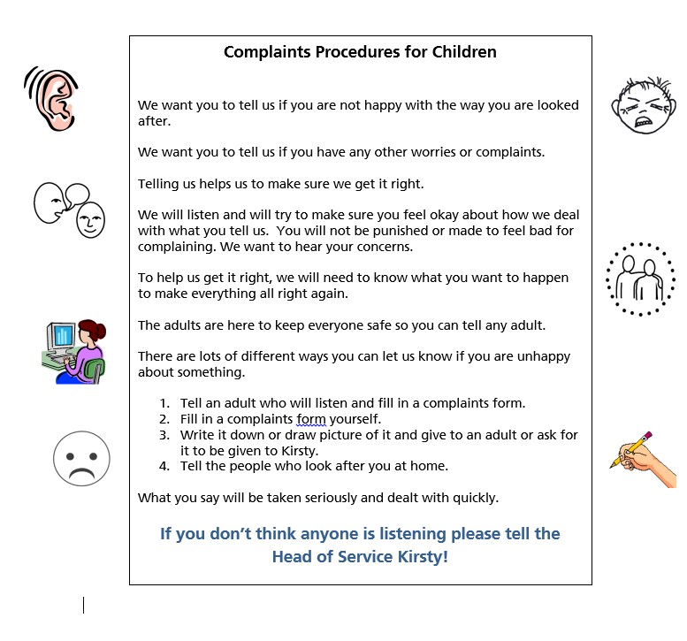

Sheet 1

Report of Complaint by a Young Person at
Gloucester House, The Tavistock Children’s Day Unit

Name: …………………………………… Date: ……………………………..

Is your complaint for you? Yes / No

If your complaint is for someone else, do they know you have complained?

Yes / No


What are you unhappy about?

How did it start? |  |  | What happened next?
How did it end? |  | What do you want to happen to sort it out?

Signed:
......................................................... Staff member / child
......................................................... Staff member / child
Date: ..........................................................
Sheet 2 (To be completed by the person managing the complaint and / or the complaints officer)

Action Taken:

- By staff member who received the complaint

- Management (if different)

- Chilo Graham, Head Teacher (Complaints Officer)
Finally – Check with the complainant by asking: “Are you happy with what has happened to sort out what you said?“ Yes/No

Signed: .......................................... Date: .......................................................

